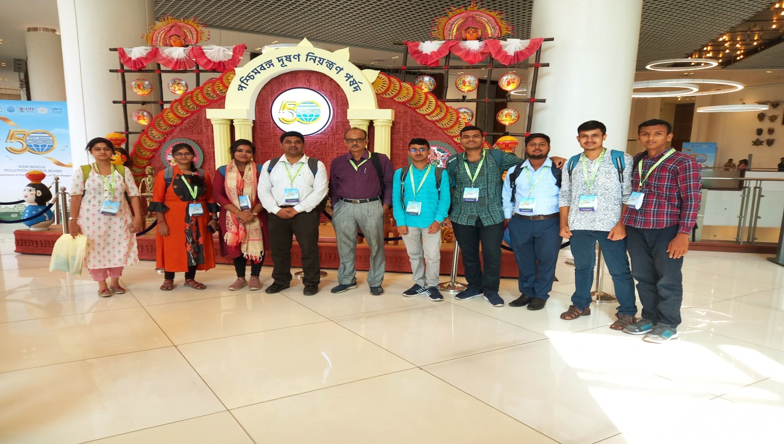
11th June 2024, WB PCB Visit, seminar and promotional programme

